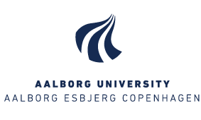
Instruction for applying for funding for further development of AAU's PBL practice (Call 2017)
You apply for funding for further development of AAU’s PBL practice by filling in the online application form.
As it is not possible to save the online application form during completion we advise you to have in information needed ready beforehand.
The online application form will require the following information:
- Name and contacts of main and co-applicants (full name, email, department/unit and faculty)
- Project title
- Short project description (max. 500 words)
- How will the project result be communication?
- How will the project be embedded and disseminated?
- Project economy – including:
Total amount applied for (max. 200,000)
Amount for VIP hours
Number of VIP hours involved
Amount for research assistance hours
Number of research assistance hours involved
Amount of TAP hours
Number of TAP hours involved
Amount for student assistance hours
Number of student assistance hours involved
Possibly expenses towards other activities (e.g. experiments during teaching)
- Project duration (start date and end date)
Please note that the theme framework for the PBL development projects is:
- PBL and digitalisation
- PBL and employability
- PBL and student retention during first year of study (undergraduate/graduate level)
The project problem must be relevant across the University and must contribute to strengthening the University’s work with PBL.
The application deadline is 1 September 2017 and the application must be approved by the head of department. All applications must be made by using the online application form and upon completion the application must be printed and signed by the head of the department and lastly, sent as a scanned copy to sts-sekretariatet@adm.aau.dk
You will find the application form here.
Any enquiries concerning the above may be directed to educational advisor Lisa Krogh Christensen at likc@adm.aau.dk or special consultant Christina Dellgren Knudsen at cdl@adm.aau.dk

